Arjun Bhan

**Create**

Drop database homework4;

create database homework4;

USE homework4;

CREATE TABLE Warehouse(

Warehouse_Number SMALLINT NOT NULL,

Space_Taken NUMERIC NOT NULL,

Space_Left NUMERIC NOT NULL,

Storage_Location VARCHAR(40) NOT NULL,

CONSTRAINT Warehouse_PK PRIMARY KEY(Warehouse_Number)

);

CREATE TABLE Customer(

Customer_UserName VARCHAR(20) NOT NULL,

Customer_Name VARCHAR(40) NOT NULL,

Customer_Email VARCHAR(30) NOT NULL,

Customer_Address VARCHAR(30) NOT NULL,

Elite_Member BOOLEAN NOT NULL,

CONSTRAINT Customer_PK PRIMARY KEY(Customer_UserName)

);

CREATE TABLE Manufacturers(

Manufacturers_ID NUMERIC NOT NULL,

Manufacturers_Name VARCHAR(40) NOT NULL,

Number_Item_Sold NUMERIC NOT NULL,

CONSTRAINT Manufacturers_PK PRIMARY KEY(Manufacturers_ID)

);

CREATE TABLE Review(

Review_Number NUMERIC NOT NULL,

Date_Reviewed VARCHAR(20) NOT NULL,

Rating DOUBLE NOT NULL,

Customer_UserName VARCHAR(20) NOT NULL,

CONSTRAINT Review_PK PRIMARY KEY(Review_Number),

CONSTRAINT Customer_FK Foreign KEY(Customer_UserName) references Customer(Customer_UserName)

);

CREATE TABLE Orders(

Product_Ordered VARCHAR(30) NOT NULL,

Time_Ordered TIME NOT NULL,

Amount_Ordered NUMERIC NOT NULL,

Customer_UserName VARCHAR(20) NOT NULL,

CONSTRAINT Orders_PK PRIMARY KEY(Product_Ordered),

CONSTRAINT Customer_FK2 Foreign KEY(Customer_UserName) references Customer(Customer_UserName)

);

CREATE TABLE Products(

Product_ID NUMERIC NOT NULL,

Product_Type VARCHAR(30) NOT NULL,

Product_Ordered VARCHAR(20) NOT NULL,

Manufacturers_ID NUMERIC NOT NULL,

CONSTRAINT Products_PK PRIMARY KEY(Product_ID),

CONSTRAINT Orders_FK Foreign KEY(Product_Ordered) references Orders(Product_Ordered),

CONSTRAINT Manufacturers_FK Foreign KEY(Manufacturers_ID) references Manufacturers(Manufacturers_ID)

);

CREATE TABLE Shipment(

Shipment_ID NUMERIC NOT NULL,

Date_Shiped DATE NOT NULL,

Shipment_Company VARCHAR(20) NOT NULL,

Warehouse_Number SMALLINT NOT NULL,

Customer_UserName VARCHAR(20) NOT NULL,

CONSTRAINT Shipment_PK PRIMARY KEY(Shipment_ID),

CONSTRAINT Warehouse_FK Foreign KEY(Warehouse_Number) references Warehouse(Warehouse_Number),

CONSTRAINT Customer_FK3 Foreign KEY(Customer_UserName) references Customer(Customer_UserName)

);

CREATE TABLE Sales(

Sale_Code NUMERIC NOT NULL,

Items_Price DECIMAL NOT NULL,

Payment_Option VARCHAR(20) NOT NULL,

Product_Ordered VARCHAR(20) NOT NULL,

CONSTRAINT Sales_PK PRIMARY KEY(Sale_Code),

CONSTRAINT Products_FK Foreign KEY(Product_Ordered) references Orders(Product_Ordered)

);

CREATE TABLE Reviews(

Review_Number NUMERIC NOT NULL,

Date_Reviewed VARCHAR(20) NOT NULL,

Rating DOUBLE NOT NULL,

Customer_UserName VARCHAR(20) NOT NULL,

CONSTRAINT Reviews_PK PRIMARY KEY(Review_Number),

CONSTRAINT Customer_FK4 Foreign KEY(Customer_UserName) references Customer(Customer_UserName)

);

CREATE TABLE Wish_List(

Wish_List_ID NUMERIC NOT NULL,

Wish_List_Title VARCHAR(20) NOT NULL,

Item_Wanted TEXT NOT NULL,

Total_Price DOUBLE NOT NULL,

Customer_UserName VARCHAR(20) NOT NULL,

CONSTRAINT Wish_List_PK PRIMARY KEY(Wish_List_ID),

CONSTRAINT Customer_FK5 Foreign KEY(Customer_UserName) references Customer(Customer_UserName)

);

**Inserts**

USE homework4;

INSERT INTO Customer VALUES("Tony_Man","Tony Tyler Black","Tony_Man@hotmail.com","Acton, MA", false);

INSERT INTO Customer VALUES("Tom Coppola","Thomas Brian Coppola","TomCop@yahoo.com","Albany, NY", true);

INSERT INTO Customer VALUES("Talia123","Talia Rachel Brown","Taltal@gmail.com","Westchester, NY",true);

INSERT INTO Customer VALUES("Gabe Mathews","Gabriel Jose Mathews","THEGAB@gmail.com","New London, CT",false);

INSERT INTO Customer VALUES("JoshDav","Josh Mario Davidson","JoshDav@hotmail.com","Boston, MA", true);

INSERT INTO Manufacturers VALUES(123,"ComputerTech",500);

INSERT INTO Manufacturers VALUES(343,"Leaf Corp",451);

INSERT INTO Manufacturers VALUES(435,"TV Makers",332);

INSERT INTO Manufacturers VALUES(400,"Leaf Corp",858);

INSERT INTO Manufacturers VALUES(789,"TV Makers",117);

INSERT INTO Wish_list VALUES(905,"Christmas List","Remote",10.50,"Gabe Mathews");

INSERT INTO Wish_list VALUES(325,"Birthday List","TV",1000.20,"Talia123");

INSERT INTO Wish_list VALUES(470,"Wish List 3","Mouse",6.00,"Tony_Man");

INSERT INTO Wish_list VALUES(261,"Christmas List","Mini TV",60.00,"Tom Coppola");

INSERT INTO Wish_list VALUES(582,"Wants","Laptop",300.75,"JoshDav");

INSERT INTO ORDERS VALUES("Radio", 1, 1, "Gabe Mathews");

INSERT INTO ORDERS VALUES("Mouse", 94320, 5, "Tony_Man");

INSERT INTO ORDERS VALUES("Laptop", 120321, 1, "Talia123");

INSERT INTO ORDERS VALUES("Remote", 54, 3, "Tom Coppola");

INSERT INTO ORDERS VALUES("Flash Light", 12453, 2, "JoshDav");

INSERT INTO Review VALUES(391,"March 12 2018",5.0,"Tony_Man");

INSERT INTO Review VALUES(874,"April 23 2019",4.5 ,"Tom Coppola");

INSERT INTO Review VALUES(542,"June 3 2018",4.0 ,"Talia123");

INSERT INTO Review VALUES(303,"May 17 2019",1.5 ,"Gabe Mathews");

INSERT INTO Review VALUES(827,"July 17 2019",2.0 ,"JoshDav");

INSERT INTO Warehouse VALUES(1, 58, 89, "Los Angeles, CA");

INSERT INTO Warehouse VALUES(2, 94, 65, "Houston,TX");

INSERT INTO Warehouse VALUES(3, 194, 6, "Albany, NY");

INSERT INTO Warehouse VALUES(4, 64, 75, "Los Angeles,CA");

INSERT INTO Warehouse VALUES(5, 155, 0, "Boston, MA");

INSERT INTO Sales VALUES(326, 90.00, "Cash","Radio");

INSERT INTO Sales VALUES(412, 10.00, "Credit Card","Mouse");

INSERT INTO Sales VALUES(600, 30.00, "Debit Card","Flash Light");

INSERT INTO Sales VALUES(554, 400.00, "Cash","Laptop");

INSERT INTO Sales VALUES(123, 90.00, "Check","Remote");

INSERT INTO Shipment VALUES(03211,'2019-10-07',"Travelers",3,"Tom Coppola");

INSERT INTO Shipment VALUES(75741,'2019-11-04',"Shippers",2,"Tony_Man");

INSERT INTO Shipment VALUES(03214,'2019-01-06',"Travelers",1,"JoshDav");

INSERT INTO Shipment VALUES(15203,'2019-12-10',"Travelers",3,"Talia123");

INSERT INTO Shipment VALUES(43256,'2019-09-09',"Travelers",3,"Gabe Mathews");

INSERT INTO PRODUCTS VALUES(48, "Controlling device", "Remote",400);

INSERT INTO PRODUCTS VALUES(94, "Communication device", "Radio",435);

INSERT INTO PRODUCTS VALUES(83, "Lighter", "Flash Light", 123);

INSERT INTO PRODUCTS VALUES(51, "Computing Device", "Laptop", 343);

INSERT INTO PRODUCTS VALUES(64, "Controlling device", "Mouse",789);

**Queries**

select Warehouse_Number, space_left

from Warehouse

order by (space_left)

;

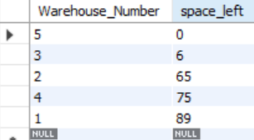

select Customer_UserName, Customer_Name, Elite_Member

from Customer

where Customer_UserName !="Tony_Man"

order by Elite_Member

;

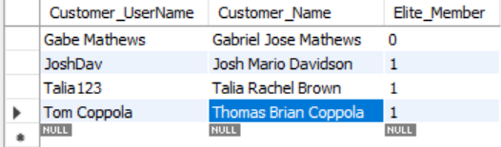

select *

from Manufacturers

where (Manufacturers_ID < 400 or Number_Item_Sold <= 500) and Manufacturers_Name = 'Leaf Corp'

;

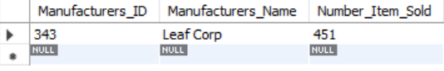

select *

from Manufacturers

order by Manufacturers_Name

;

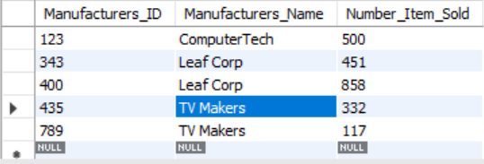

select Space_Taken

from Warehouse

where Space_Taken > (select avg(Space_Taken)

from Warehouse)

;

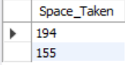

**Correlated sub-query**

select Items_Price

from Sales S1

where S1.Items_Price > ALL

(select Items_Price

from Sales S2

where S2.Sale_Code != S1.Sale_Code);



**Joins**

select Item_Wanted

from Wish_List

inner join Products on Wish_List.Item_Wanted = Product_Ordered

;

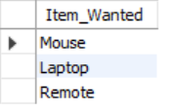

select Item_Wanted

from Wish_List

UNION

select Product_Ordered

from Products

;

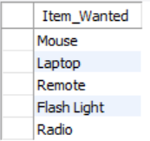



select Product_Ordered

from Wish_List

right outer join Products

on Products.Product_Ordered = Wish_List.Item_Wanted

;

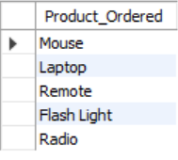

select Item_Wanted

from Wish_List

left outer join Products

on Wish_List.Item_Wanted = Products.Product_Ordered

;

